 SA10/2015 04.09.15

**UK Safety Alert**

**Tyre Incidents**

We have had a number of incidents recently involving tyre damage on large goods vehicles. Investigation into these incidents involving Continental, the company’s tyre provider, identified that they were caused by running the tyres significantly under-inflated for a period of time.

Back in 2010, we had an incident where a tyre blew out on a cement tanker, which resulted in a CEMEX employed driver being thrown approximately 20 feet across a plant yard and causing serious bruising to his lower body.

Inflation pressure strongly influences tyre rolling resistance. Under inflated tyres reduces vehicle control, increases braking distances and increases the risk of skidding. Tyre inflation also has a direct effect on vehicle emissions and fuel efficiency.

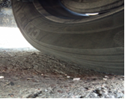

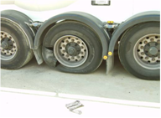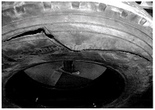

**Learning Points**

* **Tyres under-inflated by 5-10 psi are not easy to spot by their appearance, particularly on an inner tyre and especially when the vehicle is empty. Tyres under-inflated by more than 10 psi, if not rectified, can result in blow outs.** Do Drivers know what to look for when inspecting tyres as part of pre-use inspections? Are tyre checks carried out when vehicles are loaded? Always give the vehicle an additional quick check once loaded to look for issues such as under-inflated tyres or suspension problems.
* **Similar results can also be caused by damaged tyres –** When checking tyres on your vehicle, do you know what to look for? Do you know the legal tread depth? Do you have defect reporting procedures in place if you find a damaged tyre?
* **The fleet are fitted with loose nut indicators**. **Whilst these would not highlight whether a tyre is damaged or under-inflated, they do help identify the potential for wheels to work loose.** Do you have devices in place as a protective measure to identify tyre and wheel defects, such as wheel nut indicators and pressure monitors?

|  |  |  |
| --- | --- | --- |
| DE_SafetyChecks | DrivingEssentials | DE_Remember |